An Overview of the Ethical Hacking Operating System

Prepared By: Gummidipudi Jyothi kalyan

Course / Subject: Cybersecurity

Institution: Geethanjali institute of science & technology

Date: 11 September 2025

* **INTRODUCTION**

**Kali Linux** is a [**Linux distribution**](https://en.wikipedia.org/wiki/Linux_distribution)designed for [**digital forensics**](https://en.wikipedia.org/wiki/Digital_forensics) and [**penetration testing**](https://en.wikipedia.org/wiki/Penetration_test). It is maintained and funded by [**Offensive Security**](https://en.wikipedia.org/wiki/Offensive_Security). The software is based *Testing* branch of the [**Debian**](https://en.wikipedia.org/wiki/Debian) Linux Distribution: most packages Kali uses are imported from the Debian [**repositories**](https://en.wikipedia.org/wiki/Software_repository)**.** Kali Linux has gained popularity in the cybersecurity community due to its comprehensive set of tools designed for **penetration testing, vulnerability analysis, and reverse engineering.**

It was developed by Mati Aharoni and Devon Kearns of Offensive Security through the rewrite of **[BackTrack](https://en.wikipedia.org/wiki/BackTrack" \o "BackTrack)**, their previous information security testing Linux distribution based on**[Knoppix](https://en.wikipedia.org/wiki/Knoppix" \o "Knoppix)**. Kali Linux was featured in multiple episodes of the TV series [*Mr. Robot*](https://en.wikipedia.org/wiki/Mr._Robot), including software provided by Kali Linux such as **Bluesniff,**  [Bluetooth](https://en.wikipedia.org/wiki/Bluetooth) Scanner **(btscanner),** John the Ripper, Metasploit Framework, Nmap, [**Shellshock**](https://en.wikipedia.org/wiki/Shellshock_(software_bug)), and [**Wget**](https://en.wikipedia.org/wiki/Wget)**.**

* **Purpose**

The purpose of **Kali Linux** is to serve as a specialized, security-focused operating system that equips cybersecurity professionals, ethical hackers, and learners with a powerful platform for penetration testing, digital forensics, and security research. Unlike general Linux distributions, Kali is preloaded with hundreds of tools designed to test, analyze, and strengthen systems against real-world attacks. Its role extends to education and training as well, making it a go-to platform for students and security enthusiasts to gain hands-on experience. By offering a reliable, open-source, and regularly updated environment, Kali Linux enables users to identify vulnerabilities, improve defenses, and enhance overall cyber resilience.

**Why Everyone Uses It**

* **Comprehensive Toolset:** Kali includes a large collection of security and hacking tools (network scanners, password crackers, forensics, etc.) all built-in.
* **Flexible & Multi-platform:** It can run on bare metal, virtual machines (VMs), live USB, in the cloud, and even on ARM devices.
* **Rolling Release Model:** Kali is continuously updated, so tools, kernels, drivers, and security patches are regularly released. Users do not need to wait for large version upgrades to get new features.

**Specifications**

* **Supported Architectures:** x86, x86-64, various ARM architectures.
* **Kernel Type:** Monolithic Linux kernel.
* **Package Manager:** APT (Advanced Package Tool).
* **Minimum Hardware Requirements:**  
    - ~2 GB RAM for basic usage.   
    - ~20 GB disk space recommended.
* **Default Desktop Environment:** Xfce (since version 2019.4). Before that, GNOME was the default.
* **License & Source:** Open source; GNU General Public License v3.

**Why Kali Linux is Essential in the Cybersecurity Domain**

* Kali Linux is considered one of the most essential platforms in cybersecurity because it integrates a wide range of tools and resources into a single, specialized operating system, designed specifically for security testing and analysis. In today’s digital world, organizations face constant threats from malware, phishing, ransomware, and advanced persistent attacks. Kali Linux allows security professionals to simulate these attacks in a legal and controlled environment, so they can discover vulnerabilities in networks, applications, and operating systems before malicious hackers exploit them.
* Another reason for its importance is that it is open-source and free, meaning students, researchers, and professionals worldwide can access it without licensing costs. It comes pre-installed with over **600 tools** that cover every area of cybersecurity, including **network scanning (Nmap)**, **password cracking (John the Ripper, Hydra)**, **wireless testing (Aircrack-ng)**, **web application testing (Burp Suite, OWASP tools)**, and **exploitation (Metasploit Framework)**. Instead of installing each tool separately, users get an all-in-one package, which saves time and ensures compatibility.
* Objective:

The main objective of this project is to gain practical knowledge and hands-on experience in using **Kali Linux**, a widely used cybersecurity operating system. The project focuses on four key tasks:

1. **Installation** – To set up Kali Linux in a secure and controlled environment using virtualization, ensuring that the system is properly configured for cybersecurity operations.
   * 1. **Virtualization**: it’s the process of running multiple operating systems into one physical devices.
2. **Updates** – To keep the operating system up to date by performing regular updates and upgrades, which are essential for maintaining security patches, tool enhancements, and overall system stability.
3. **MAC Address Spoofing** – To understand and demonstrate how to change a system’s Media Access Control (MAC) address using specialized tools, which is a valuable technique for anonymity, privacy, and penetration testing exercises.
4. **User Management** – To learn how to create, manage, and assign roles to users, including granting administrative privileges, which is critical for implementing access control and maintaining system security.

The objective of this project is to explore and demonstrate the practical use of **Kali Linux** as a cybersecurity-focused operating system. The project specifically aims to cover four key areas: the installation of Kali Linux in a secure environment, performing system updates and upgrades to ensure stability and security, conducting **MAC address spoofing** to understand its role in anonymity and penetration testing, and practicing **user management** to learn how to create, modify, and control user accounts with different privilege levels. By completing these tasks, the project helps in developing a strong foundation in ethical hacking practices, system administration, and real-world cybersecurity operations.

**Setup**

Before beginning the project, it is important to identify the **hardware and software prerequisites** required for running Kali Linux effectively.

**Hardware Requirements:**

* Processor: Dual-core CPU or higher (64-bit recommended)
* RAM: Minimum **2 GB** (recommended **4 GB or more**)
* Hard Disk: Minimum **20 GB** (recommended **40 GB or more**)
* Graphics: Standard VGA support
* Internet Connection: Required for updates and package installations

**Software Requirements:**

* **Kali Linux ISO image**

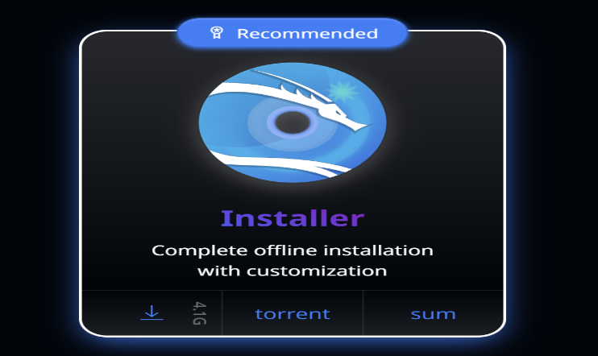

* **Virtualization software** such as:
  + **Oracle VirtualBox** (free and open-source)
  + **VMware Workstation Player** (free for non-commercial use)

**Need for Virtualization**

Virtualization is essential for this project because it allows Kali Linux to run in a **virtual machine (VM)** without affecting the host operating system. This provides a **safe, isolated, and controlled environment** for experimenting with penetration testing and system configurations. Using tools like **VirtualBox** or **VMware**, students can easily install, reset, and configure Kali Linux multiple times without risking their primary computer. Virtualization also supports features like snapshots, portability, and resource allocation, making it the most practical way to learn and test cybersecurity operations.

* **Installation**:
  + 1. **Steps to install Virtual Box:**

**Step 1:** Download Virtual Box

->Go to the official website: <https://www.virtualbox.org/>

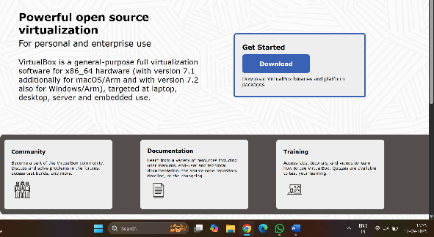

->Navigate to Downloads and select Windows Hosts.

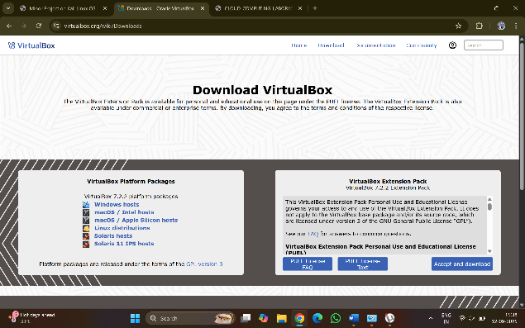

**Step 2:** Run the Installer file

**->**Go to downloads and double click on the file and click on install.

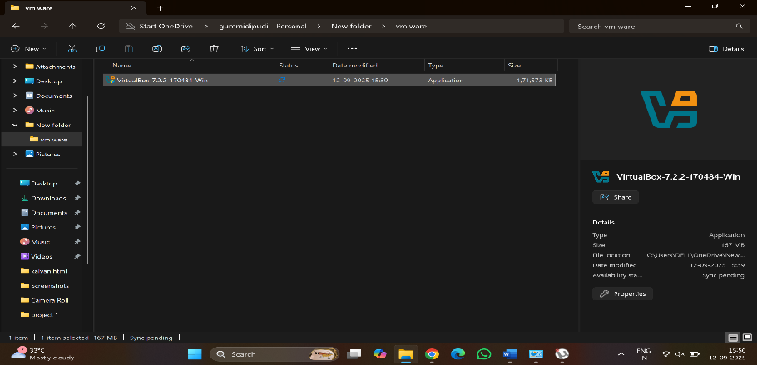

**Step 3:** Follow the instructions on the screen

1. Click on the next button.

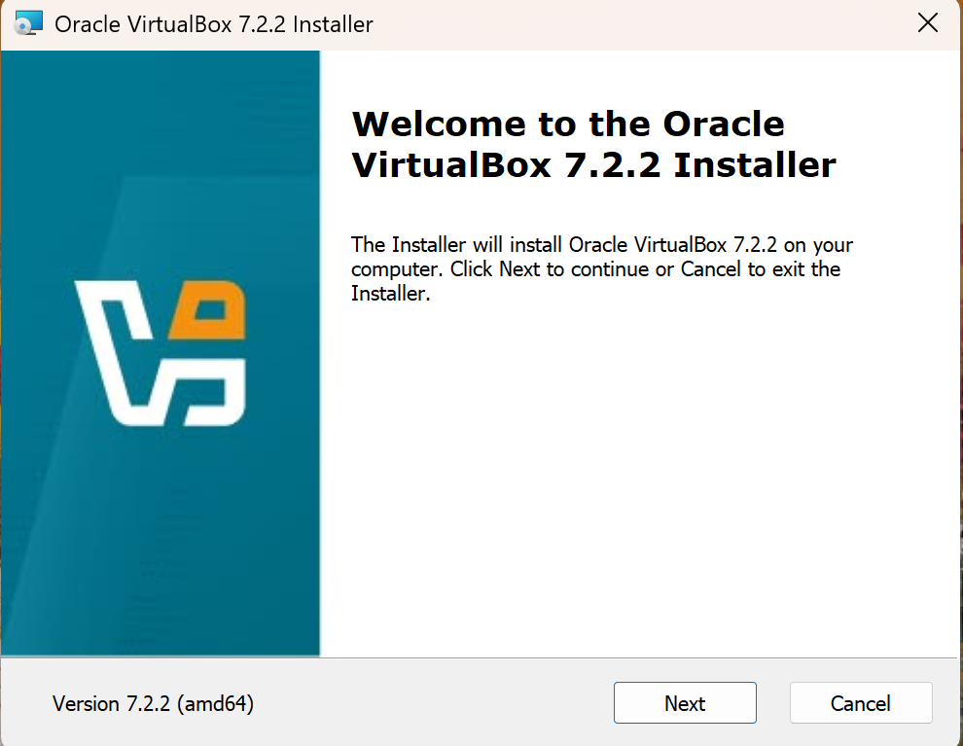

1. Accept the term and condition and click on next.

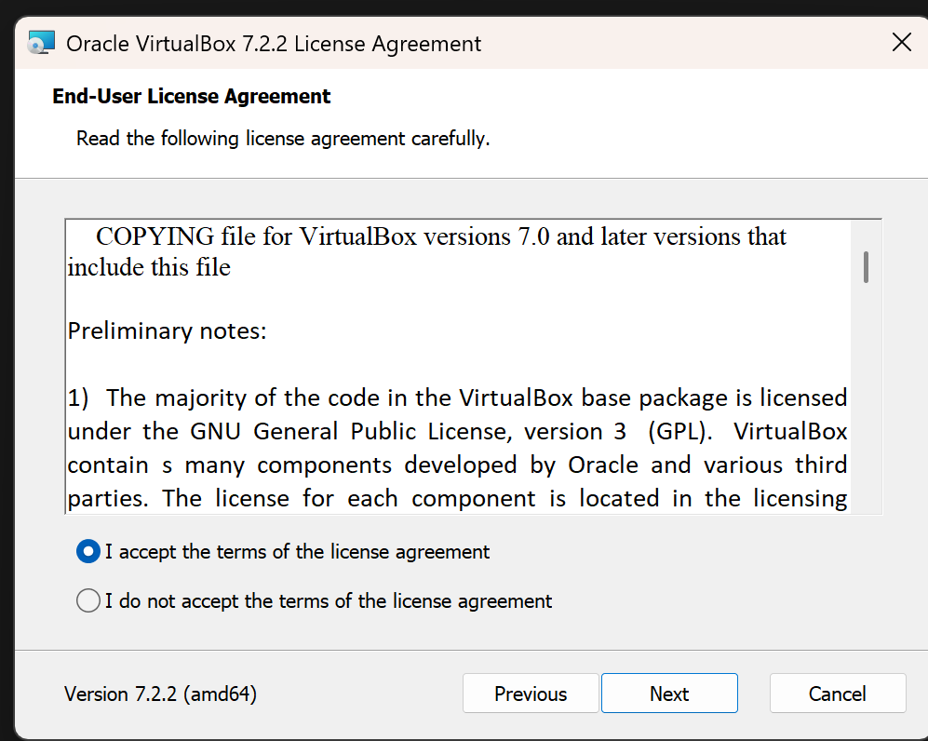

1. Accept the custom setup and select the features to

install and click on next

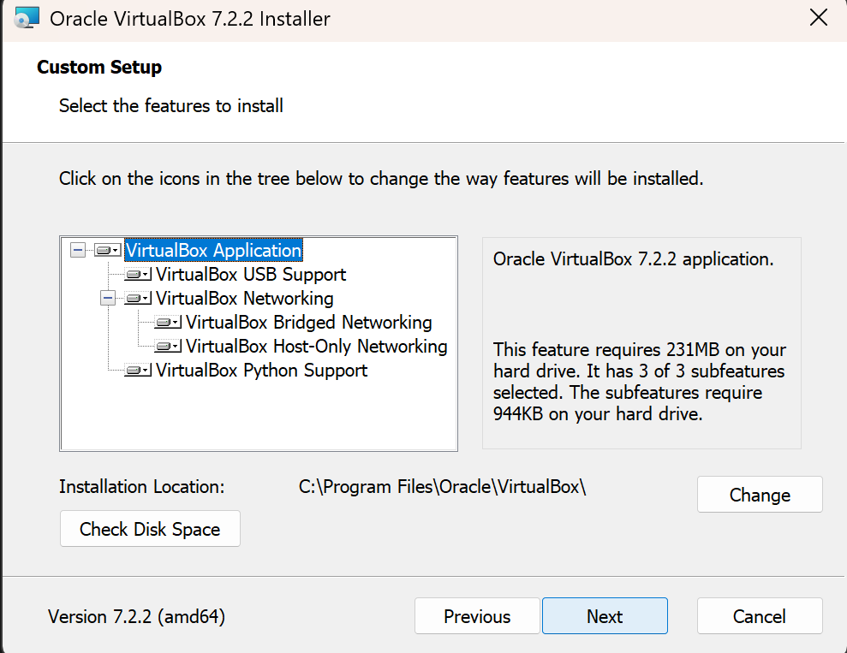

1. Network disconnection warning by the oracle virtual box.

Click on yes to network disconnection.

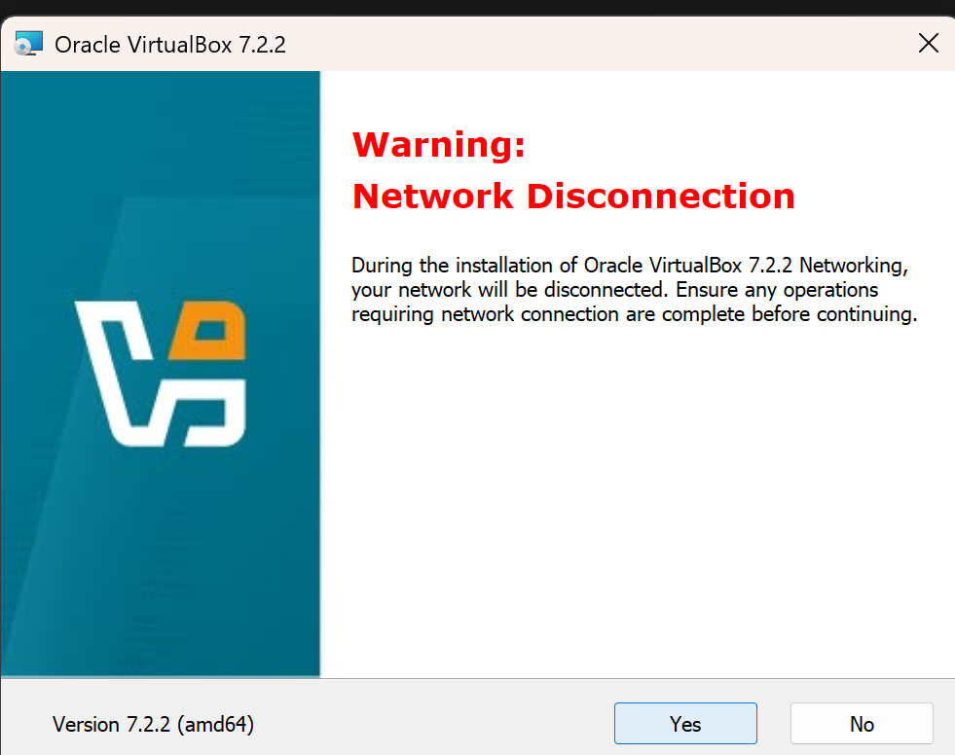

1. Select the features to install and click on next.

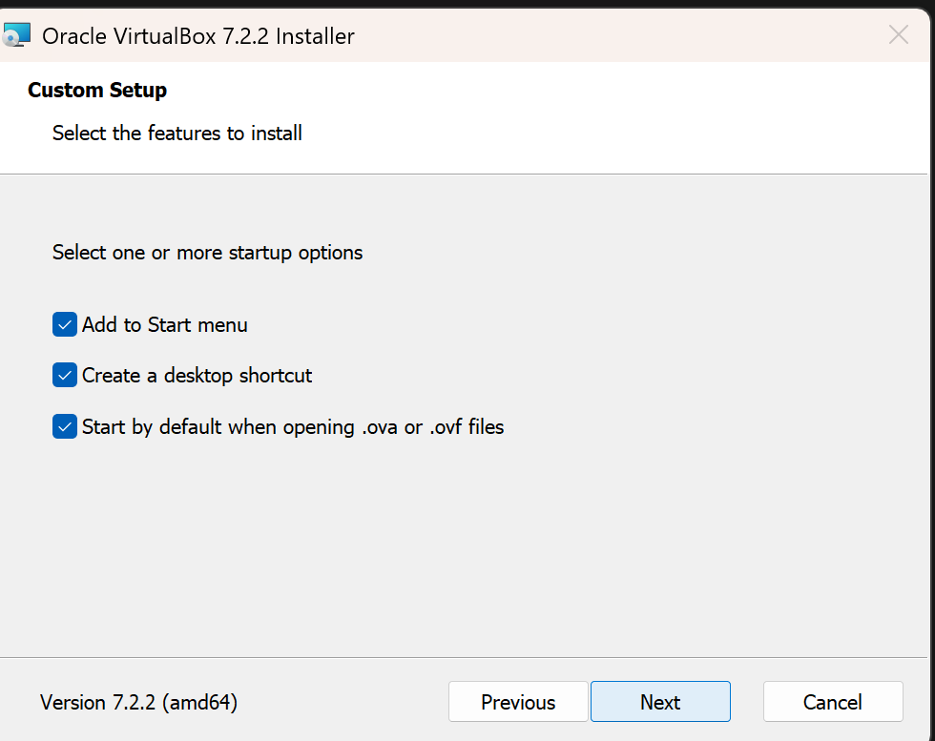

1. Click on install to get the virtual box instal.

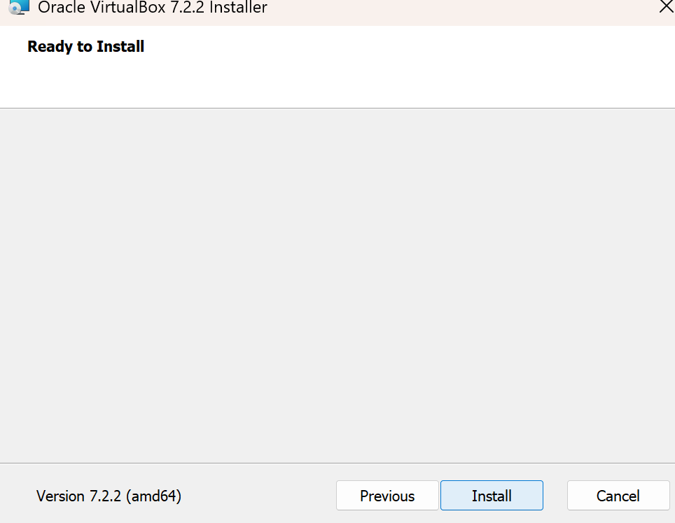

1. After clicking the next the installation process will start.

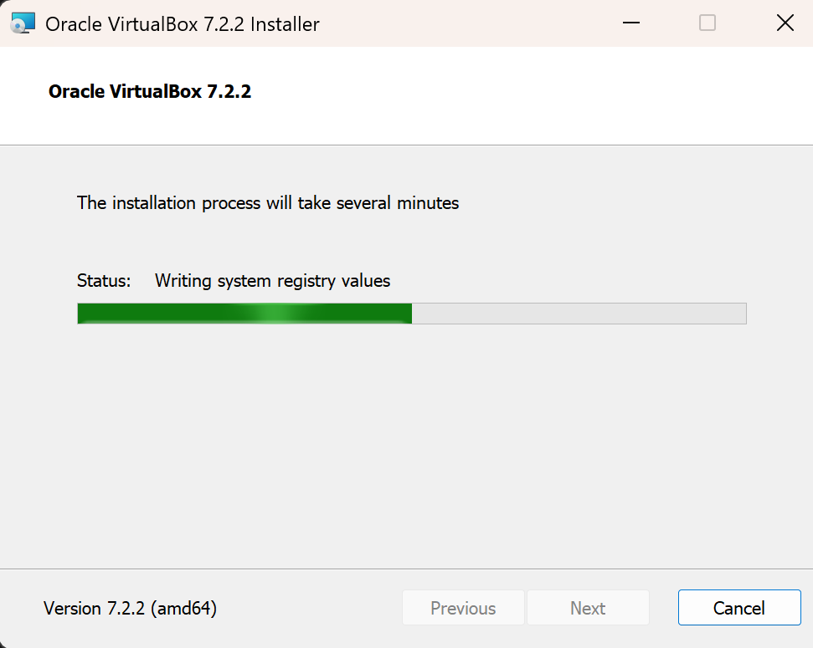

1. Oracle virtual box 7.2.2 has been successfully installed in your System or pc. Then click on finish to complete the process.

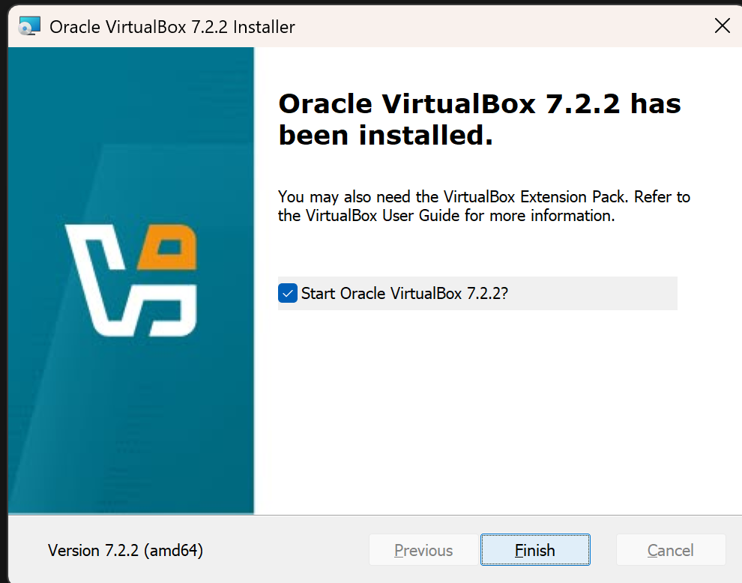

* + 1. **Steps to install kali linux os**

**Step 1**: Download Kali linux

->Go to the official website: <https://www.kali.org/get-kali/>

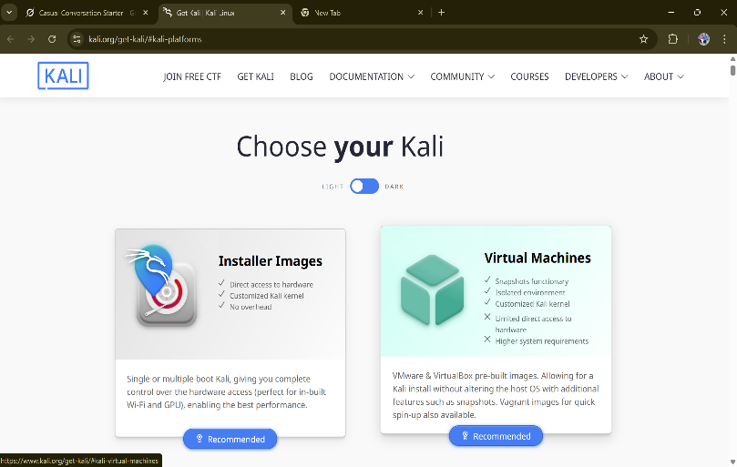

**->**There are many specification on kali linuxand

Download based on the needs.

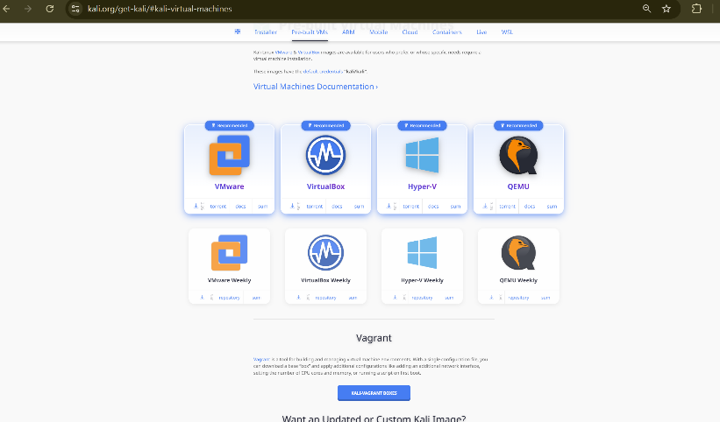

**Step 2:** After downloading the file double click on it to extract the file.

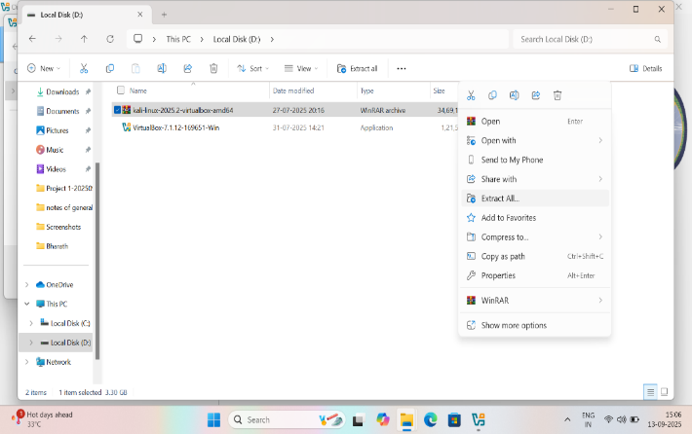

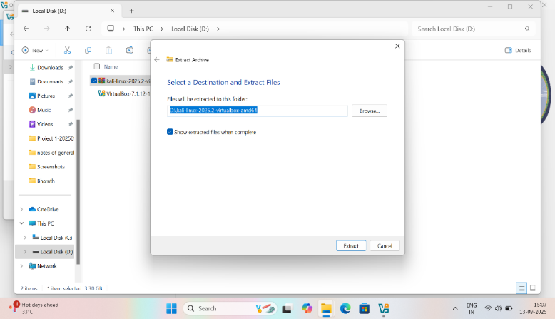

**Step 3**: open the virtual box and click on add button.

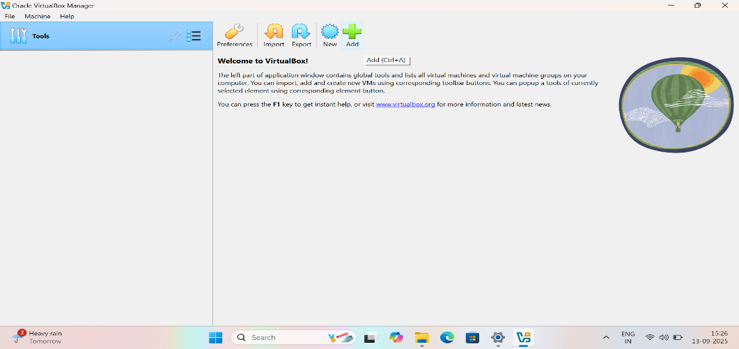

**Step 4:** Import the kali linux from file explorer.

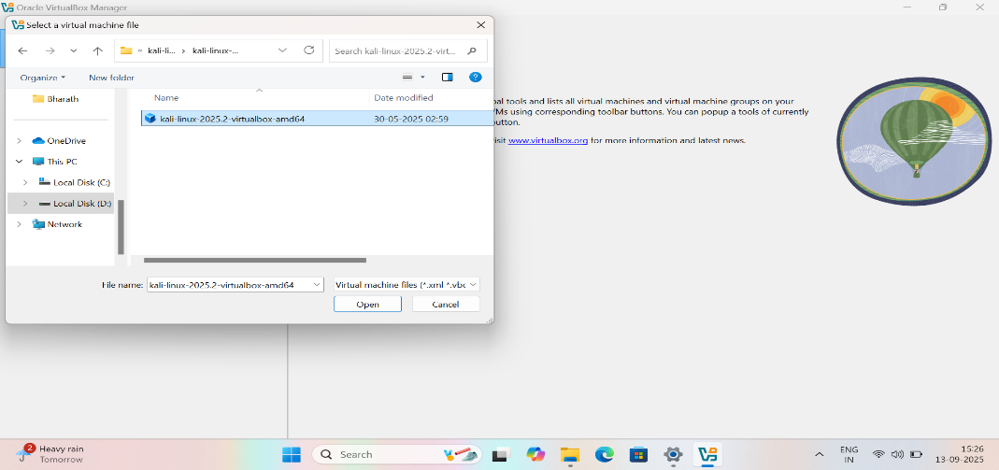

**Step 5:**After extracting kali is stored in the virtual box.

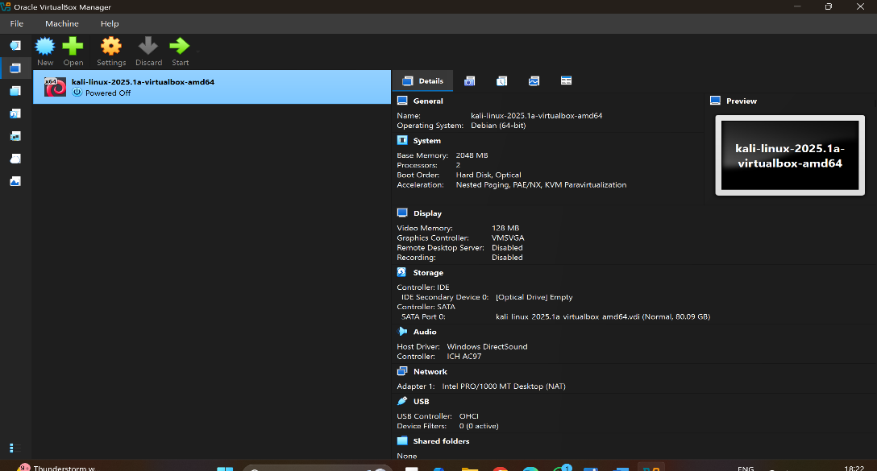

**Step 6:** Double click on the kali linux the it start running on your

Virtual box.

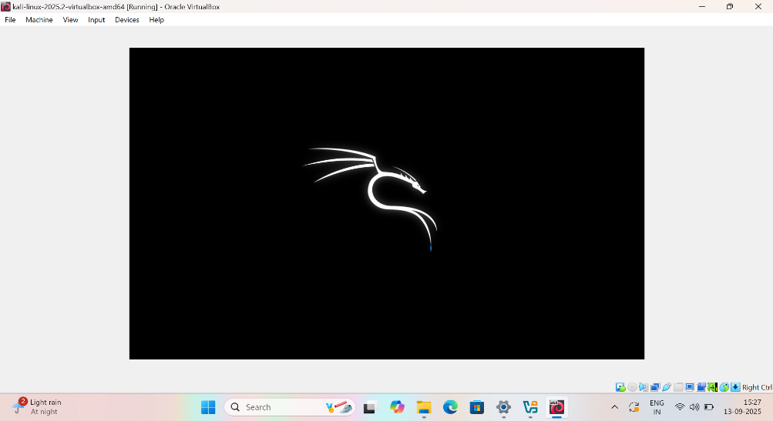

**Step 7:** Enter the default password for login.

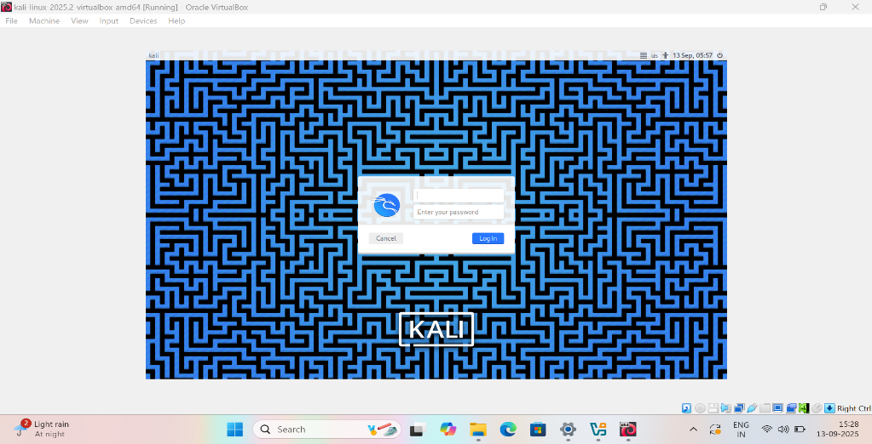

**Step 8:** The installation of kali linux in virtual box is successfully

Completed.



* **Update & upgrade**

**Step 1:** open terminal and enter the command to update the terminal.

**Command**: sudo apt update

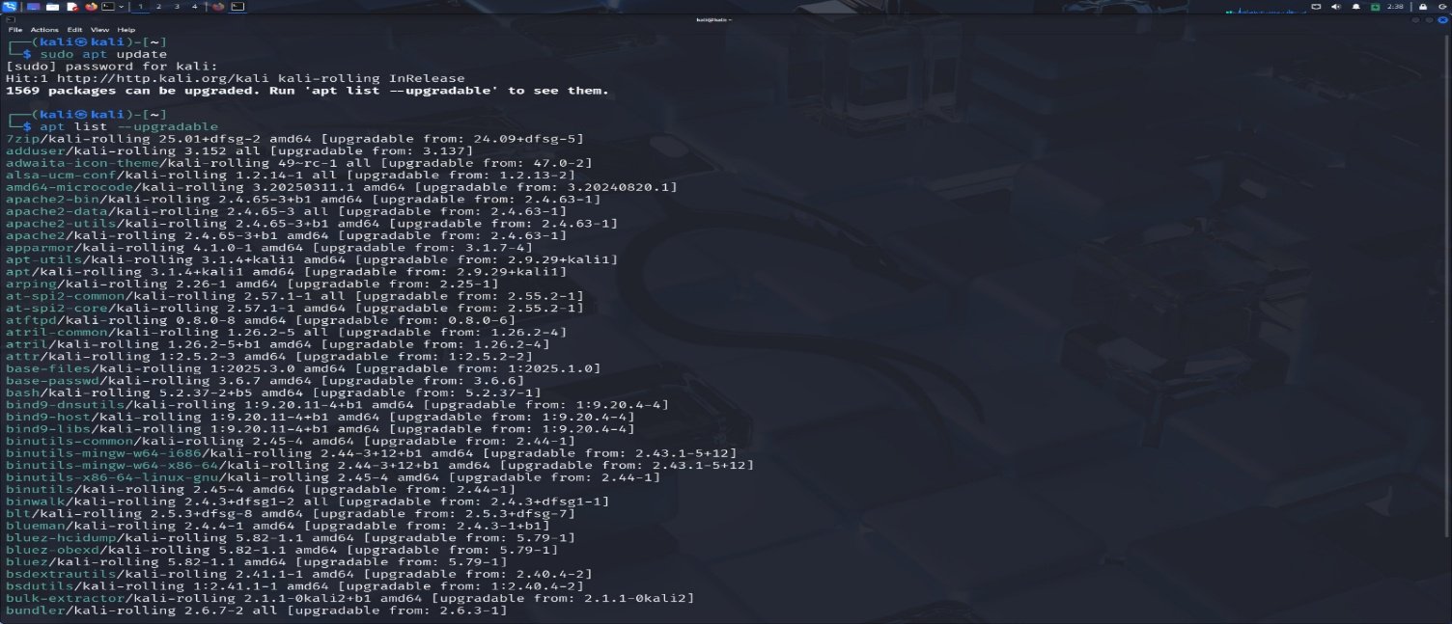

**Step 2:** After completing the update then proceed with upgrade.

**Command:** sudo apt upgrade -y

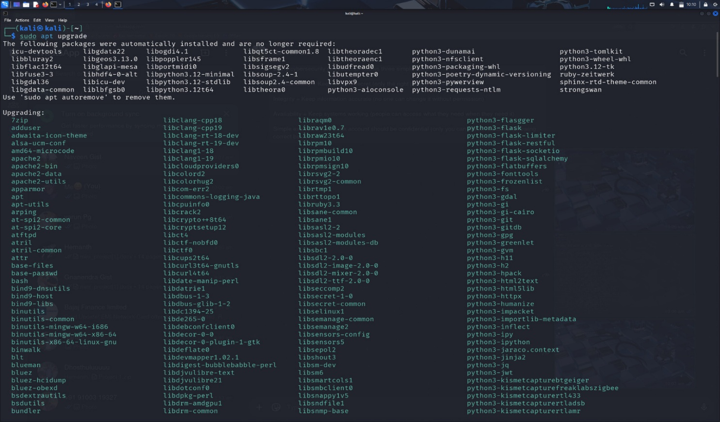

* **MAC Address Spoofing**

Mac address spoofing is the process of changing the mac address of the device to hide its real identity.

**Steps for Mac address spoofing:**

**Step 1:** open terminal and install mac changer.

Command: sudo apt install macchanger.

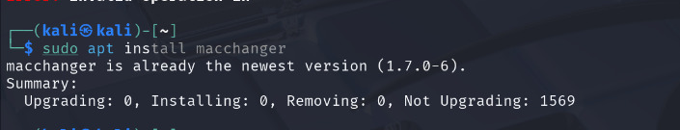

**Step 2:** check your ip and mac address before changing the mac address.

Command: ip link show

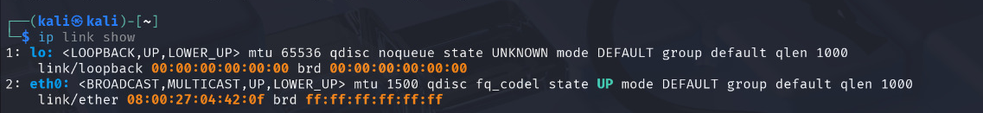

**Step 3:** check your ip configuration**.**

Command: ipconfig

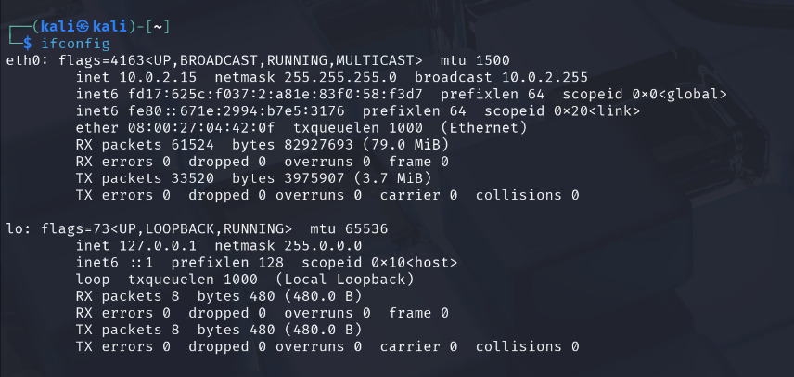

**Step 4:** Enter thecommand to change the mac address**.**

Command: sudo macchanger -r eth0

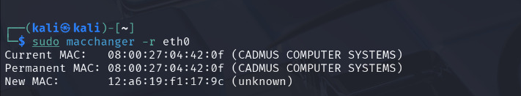

**Step 5:** check your ip and mac address again to verify if it’s changed or

not.

Command: ip link show

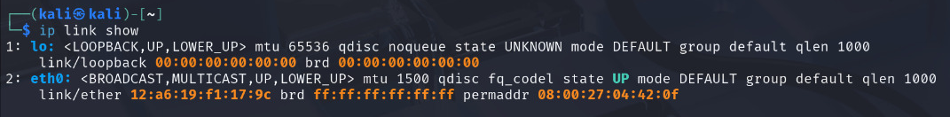

**Step 6:** Againcheck your ip configuration**.**

Command: ipconfig

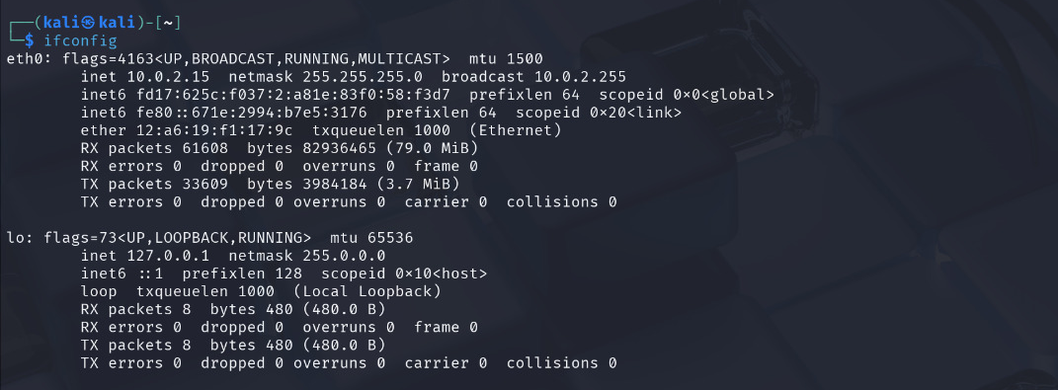

We successfully completed MAC Address Spoofing our mac address is changed.

* **User Management:**

User management is use to add a new user and assigin administrative

privileges.

**Step 1:** Open terminal and add new user and create new password**.**

Command: sudo adduser testuser

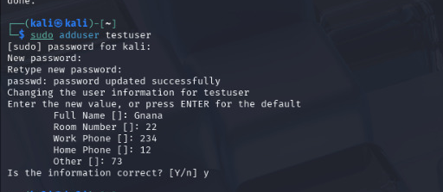

**Step 2:** Give your admin rights to the user**.**

Command: sudo usermod -aG sudo testuser



**Step 3:** Switch useron the terminal.

Command: su - testuser

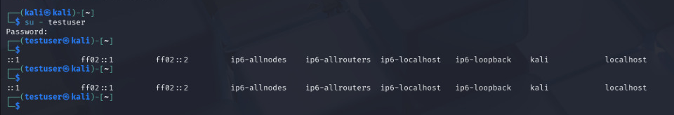

**Reflection:**

Cybersecurity is like being a digital bodyguard - protecting computers, networks, and information from bad people who want to steal, damage, or misuse them. Just like you lock your house to keep burglars out, cybersecurity locks digital doors to keep hackers out.

The Three Most Important Things I Learned

1. **The CIA Rule (Not the spy agency!)**

Every cybersecurity professional follows three simple rules :

**Confidentiality** = Keep secrets secret (only the right people can see information)

**Integrity** = Keep information accurate (no one can change it without permission)

**Availability** = Keep systems working (people can access what they need when they need it)

**Simple example**: Your bank account should be confidential (only you can see it), accurate (showing correct balance), and available (you can check it anytime).

2. **Good Guys vs Bad Guys**

I learned there are two types of hackers :

**Bad hackers (criminals)** = Want to steal money, data, or cause damage

**Good hackers (ethical hackers)** = Help companies find problems before criminals do

**What I do with Kali Linux:** I'm learning to be a "good hacker" who helps protect people instead of hurting them.

3. **Defense Has Many Layers**

Cybersecurity is like an onion - it has many protective layers :

**Firewalls** = Digital walls that block bad traffic

**Antivirus** = Software that finds and removes viruses

**Strong passwords** = Hard-to-guess keys to your accounts

**Updates** = Fixes for security holes

**Backups** = Copies of important files in case something goes wrong